|  |  |
| --- | --- |
| **Project title** | **Memory Game** |
| **Author(s)** | **Grigoruț Dominic-Octavian** |
| **Group** | **30423** |
|  |  |
|  |  |

Cuprins

1. Task Description 2

2. Class Diagram 2

3. Application Overview 3

4. Application Tests 6

# Task Description

The application is a minigame in JavaFX, simulating the famous game Memory. You are presented with cards that are faced down and in turns you make guesses to try and uncover each pair. For each correct guess you get 100 points and for each wrong guess you are penalized with 10 points.

The game has 4 level, the number of cards being increased from level to level. At the end your score will be compared with the high score and if it is greater it will become the new high score.

# Class Diagram

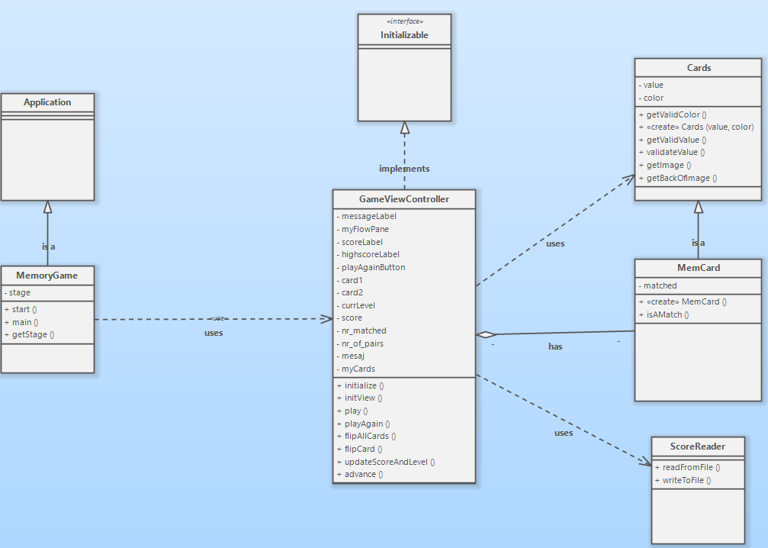

# Application Overview

When you enter the application you are instantly greeted with the first level of the game.

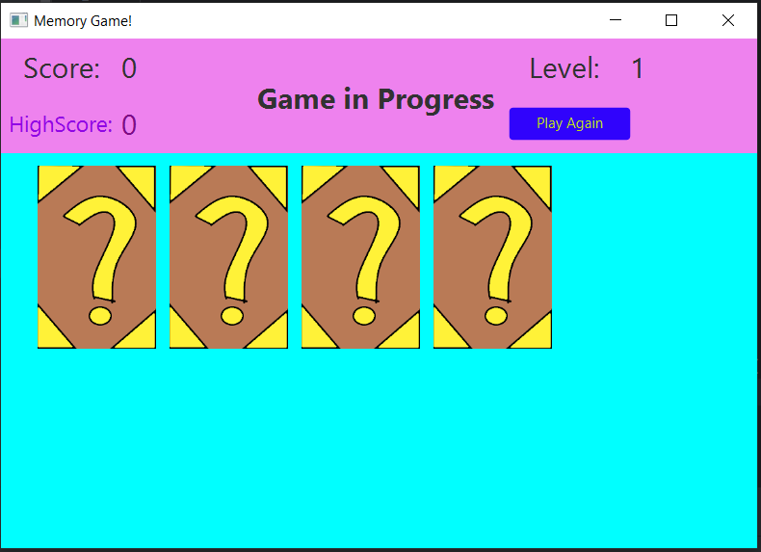

You have to click on a card and it will turn to its face and reveal its color and shape(value). These attributes are decided at the beginning of each level randomly making use of the getValidColor() and getValidValue from the Cards class. There are in total 16 combinations of value and color.

When a guess is wrong the score decreases by 10 points and when a guess is correct the score increases by 100.

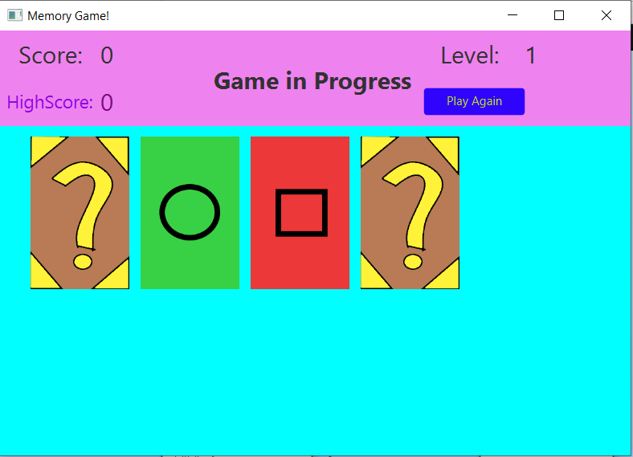

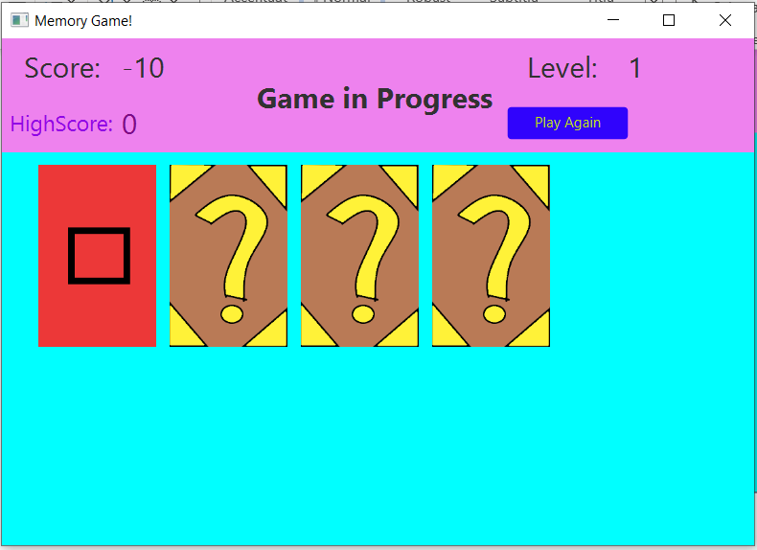

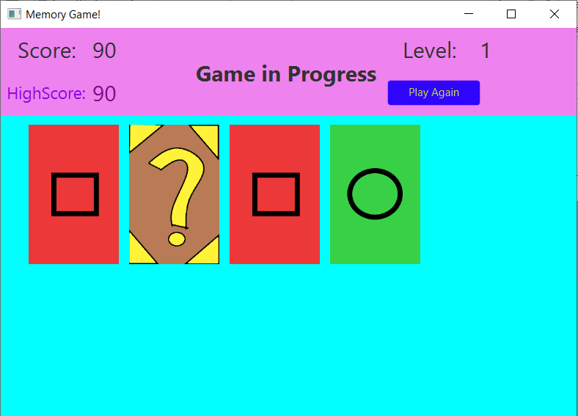

After a correct guess the card remain on their faces for the rest of the level.

The game continues up until level 4 where we have to search for pairs in a deck of 10 cards. After completing the final level the game will display the message “Game Finished” and if the player presses the “Play Again” button the game will restart.

# Application Tests

The project has tests for the ScoreReader methods: reading and writing from a file; for MemCard: if the values are in the values domain(“red”, “blue”, ”green”, “yellow”), if the color are in the color domain values(“square”, “circle”, ”triangle”, ”star”) and the isAMatch() method; and for the GameViewController tests if several object are initialized in the view.

